Cover Page
Institution: Boston Institute of Analytics
Project: IT Capstone
Project Title: Types of SQL Injection
Student Name: Rishi Kirtikumar Ponkya
Module Name: Cybersecurity & Ethical Hacking
Lecturer Name: Shane
Submission Date: 10th July 2026

Table of Contents
Abstract
Chapter 1: Introduction
  - Introduction
  - Structured Query Language
  - Database
  - SQL Injection
  - Cause of SQL Injection
  - Impact of SQL Injection

2. Types of SQL Injection
2.1 In- Band SQL Injection
- Error Bases SQL Injection
- Union Based SQL Injection
2.2 Inferential Blind SQL Injection
- Boolean Based – Blind SQL Injection
- Time Based Blind SQL Injection
2.4 Out of band SQL Injection

3. Research
3.1 Selected Website/Lab
3.2 Website Details
3.3 Category and Purpose
3.4 Popularity and Usage

4.Data Collection
4.1 Technology Stack
4.2 Web Server
4.3 Programming Language
4,.4 Database
4.5 Operating System
4.6 Tools Used

5. Chapter 5: Proof of Concept
5.1 Lab Environment
5.2 Demonstration
5.3 Results
5.4 Screenshots

6. Chapter 6: Impact Analysis
7.Chapter 7: Recommendations
References

Abstract
I set out to explore the different kinds of SQL injection and put one into practice in a controlled lab setting. For this, I used PortSwigger’s Web Security Academy and pulled off a union-based SQL injection attack. I managed to grab the admin credentials and log in to the app with full administrator access. In this report, you will find everything, I did my research, how I collected data, the proof-of-concept attack, what it all means and some recommendations for the future.

Chapter 1
  - Introduction
This report consist of 7 chapters, starts off from chapter 1 which covers the background information of SQL injection, databases, information on SQL and covers it impacts and causes. Second phase of this report start from chapter 2 which covers the different types of SQL injection that includes 3 aspects which are in band (union-based and error-based), inferential blind (Boolean-based and time-based) and the final aspect is out -of -band techniques. Chapter 3 focuses on the research approach into selected platforms used for the report’s practical components. Phase 4 of the report covers data collection on technology stack of the target website. Chapter 5 focuses on the Proof of Concept, describing the lab environment, chapter 5 includes a step-by-step demonstration of the union-based SQL Injection attack, the chapter than gives the results achieved and supporting screenshots used. The impact analysis of SQL injection in chapter 6 showcases both general and specific of the different types demonstrated in the previous chapters. The final chapter of the report focuses on mitigation techniques for preventing SQL injections and recommendation, which links back to vulnerabilities exploited in previous chapter of this report. This research report ends with a reference list from where I gather all my information and research.

  - What is SQL?
SQL refers to Structured Query Language (SQL) is the collection of statements with which all programs and users access data in an Oracle Database. Applications Programs and oracle tools often allow users access the database without using SQL directly but these applications in turn must use SQL when using the user’s request. This chapter gives us background information on SQL as used by more database systems.

1.3 What Is a Database?
A database is an electronically stored systematic collection of data. It can contain any type data including words, numbers, images, videos and files. Databases are mainly used for businesses and web application that provides us a structure way to store the large amount of information and give access to users to retrieve information quickly whenever its needed.

  - SQL Injection
SQL Injection refers to a web application security vulnerability that allows attacker to interfere with SQL queries that an application sends it to the database. It allows attacker to view data that that are simpler able to get it back. These can include additional data that belongs to other users, or any other data that the application can also have access for it. In lots of cases an attacker can modify or delete this data causing permanent changes to the application’s content behaviour. In many problematic situations, SQL injection attack can be utilized to compromise the underlying server or other back-end infrastructure. It can allow an attacker to perform denial of service attacks.

  - Causes of SQL Injection
While the main reason behind the occurrence of the SQL injections lies in the way the user input is handled unsafely in the SQL queries, there are other elements that contribute to this problem as well. Knowing about them will help pot the vulnerabilities in the early stages of development of the application. The SQL injections can be really bad because they let attackers do things they should not be able to do, like access our data or run commands from the database so we need to make sure we handled user input safely to prevent the SQL Injections.

  - Impact of SQL Injection
The Key Impacts of SQL Injection are discussed below:

- Confidentiality: SQL databases contain private data. Therefore, lack of confidentiality is a major impact in case of vulnerabilities in SQL Injection.
- Authentication: In cases of the use of weak SQL commands to authenticate username and passwords, it becomes easy for an attacker to log into the system as another user without knowing his password.
- Authorisation: In case like authorisation details are kept in the SQL database, the details can be manipulated by taking advantage of the SQL Injection weakness.
- Integrity: While attackers can easily view confidential data from the database using the SQL Injection technique, they can also manipulate and destroy such data.

Chapter 2: Types of SQL Injection
2.1 In band SQL Injection
- Error based SQL Injection
Error Based SQL Injection are those instances where you will be able to extract or guess the sensitive data in the database using the error message, even when it is done blind. The configuration of the database might at times lead to error messages that are lengthy. This kind of information can at times be helpful to the attacker. At times, you will be able to cause the application to produce an error message, which contains part of the data that has been produced by the query. While SQL Injection using errors is good in profiling a database, it shows a great information leak threat.

- Union Based SQL Injection
Union Based SQL Injection refers to the use of the union statement in SQL when combining the result of the original query and the result of the second, attacker’s query. This attack occurs as the output of both queries is projected as a single result. To conduct this type of attack, the number of columns in the injected SELECT statement should be equal to the original query, also the injected should have the same type as the one used in the original request. Hackers usually figure out the number of columns first (by means of the ORDER BY or Union SELECT NULL techniques), then find out which of those can be used for inserting the text and finally make use of it to retrieve the needed information from the database (It is included in the name of tables, columns and passwords).

2.2 Inferential Blind SQL Injection
In Blind SQL Injection, there is no report provided on whether the SQL query executed successfully and neither are there any database or application error messages provided to the attacker. Rather, it requires more effort from the attacker as he or she is required to rely on the behaviour of the attacker to determine if the injection was successful.

- Boolean Based- Blind SQL Injection
Boolean Based SQL Injection is a method that focuses on sending an SQL query to the database on which the method forces the application to return unique results. The outcome allows an attacker to inspect whether the payload used returns true or false. Even though no data from the database is retrieved, the results give the attacker useful information. The mechanism for the passwords to configure it. The attacker verifies first letter of the password at a time, while trying it if the output gives you a false verdict, then must go for different letter for the same position but if a statement gives you true then an attacker moves to the other letter of the password that slowly gets attacker to the password and it built up in this way.

- Time Based Blind SQL Injection
Unlike Boolean based SQL injection, where the pages has clearly difference in content for true or false while on the other side in time-based SQL injection content are not visible in pages and in time based SQL injection timing is use instead of content page, Time-Based SQL injection may be possible to use the blind SQL injection causing vulnerability by encountering time delays that mainly focuses on whether a injects condition is true or false. Signals that are being used by attackers would be if the result is delivered instantly or perhaps it has been pause or holding it probably that would be the attacker signal. While taking a delay to triggered it means attacker is getting to the password if it gives an instant outcome to it then the password letter would be incorrect so it give attacker instant outcome, but there could be different scenario as well if it delays it means attacker has cracked it and outcome results to true, that means slow slowly attacker is getting to the users credentials or password. The methods for testing a time delay can particularly type of database is being used. Testing each letter for the password it contains user’s information from that an attacker can take character at a time from the user’s real data.

2.4 Out of Band SQL Injection
In Out of Band SQL Injection the database sends a request to the server and attacker has controls of it. The data that is stolen by attacker inside the request of outbound request it is involved in web address itself. It is only successful attempt when the requests from the outbound are allowed by the server or database is configured. The attacker must request one piece at a time of the so the method can be implemented at a same time.

Chapter 3 Research

3.1 Website/Lab
The Platform I decided to make use of this one because it is authorised by the law and it has received authorisation to undergo test. This seems to be the bet platform in relation to development as it provides to test those apps that are exposed to the internet or the ones exposed to any kinds of SQL injection for free as it is made in use just for this specific reason.
3.2 Website Details
- Name of the Website: PortSwigger Web Security Academy
- URL: https://portswigger.net/web-security
- Owner of The Website: Port Swigger with a link to Burp Suite.
- Lab used: I made use of the SQL Injection Lab that involves union attack on several different numbers of columns, also extracting data from several different tables.

3.3 Category and Purpose for the Website.
Types and Goals According to the purpose it serves, the websites fit under the type of training programs that is available online. This academy serves to train and develop people’s understanding regarding to typical web vulnerabilities that exists online.

3.4 Popularity and Usage
One of the top free websites used for educating on web security is Port Swigger’s Web Security Academy. Other institutions like OWASP use this resource in cybersecurity courses and in teaching on ethical hacking.

Chapter 4
Data Collection
Wappalyzer was used to research out with what technology portswigger.net is built with.

Technologies Detected
- Analytics
- Post Hog, Matomo Analytics, LinkedIn Insight Tag, Google Ads Conversion Tracking.
- Tag Managers
Google Tag Manager
- CDN
Amazon Cloud Front
- Marketing Automation
Salesforce Marketing Cloud Account Engagement
- JavaScript Libraries
Lazy Sizes
- Hosting/cloud
Amazon Web Services
- Miscellaneous
Open Graph
- Programming
None identified in this scan (Wappalyzer sometimes doesn’t pick up frameworks that are abstracted away.
- Security
No security related software flagged apart from inherent services like AWS/CloudFront Protections.

Chapter 5

Proof of Concept

5.1 Lab Environment

The Platform I used for the practical and to solve the lab is portswigger, lab I was working on it was SQL Injection UNION ATTACK retrieving data from other tables and I used a web browser to perform it and used browser URL bar to inject payloads.

5.2 Demonstration

- Step 1
I went ahead and click on the GIFTS tab, where I can see the URL parameter is called category=Gifts, so I then proceeded to add single quotes to the end of it and, I noticed an Internal Server Error.

- Step 2
I was thinking to know the number of columns the query return, I will append ORDER BY to the URL and increase the value 1,2 and 3 to my surprise, at 1 and 2 the page returned normal result but at 3 it gave me error again.

- Step 3
I have noticed this since the error only came at ORDER BY 3 and not at 1 or 2 I was told that my query is returning 2 columns.

- Step 4
While trying different injection in URL bar, then I tried for union SELECT NULL which loaded the page normally and gave me the good accurate result for it.

- Step 5
I tried injection on my URL bar which was UNION SELECT ‘a’ NULL which didn’t give me a error it gives me the good outcome what I needed, no error for it.
- Step 6
I tried UNION SELECT username, password FROM users on my URL bar and it showed in three different users, and the injection the URL bar was successful.

- Step 7
After that I tried logging in the credentials on the login page with the username administrator and password v3m3r0z9cbp2tyon4e ok and then status changed from not solved to solved.

5.3 Results

While summarising it, the attack was successful. This clearly illustrates that the category parameter can be vulnerable to UNION based SQL injection. The success gave me confidence to do it and the admin user as well as password also allowed me to access through the admin

In summary, the SQL injection was successful. This shows that the category parameter can be vulnerable to SQL Injection through unions. This success enabled me to dump out the admin user as well as his/her password hence allowing me access through the admin.

5.4 Screenshots

Step 1:
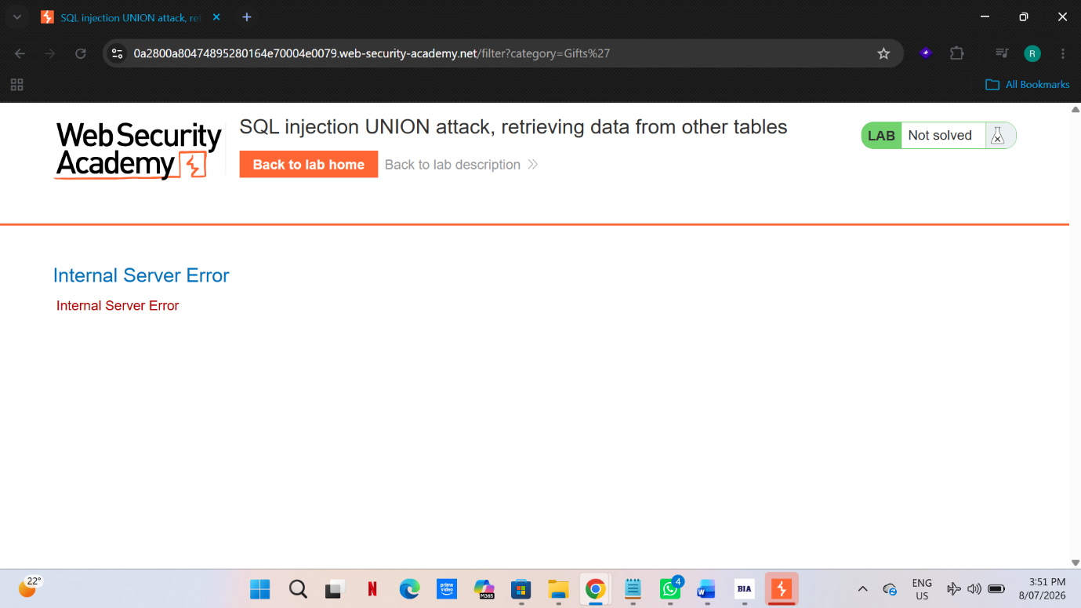

Step 2:

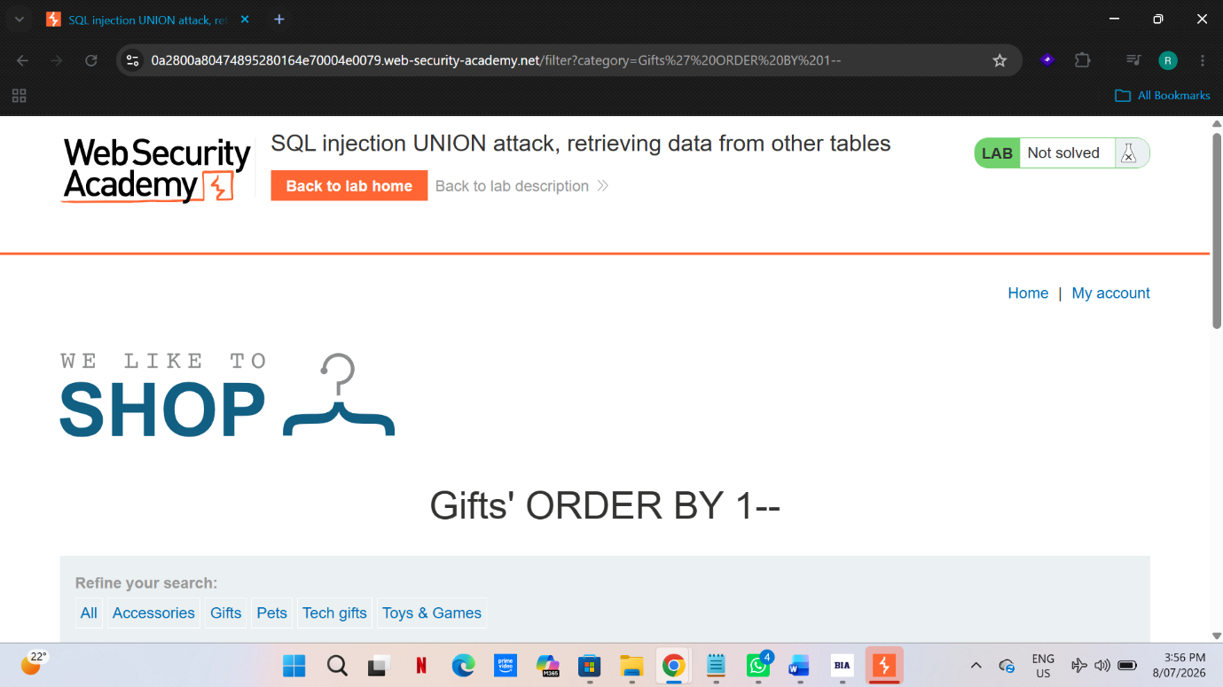

Step 3:
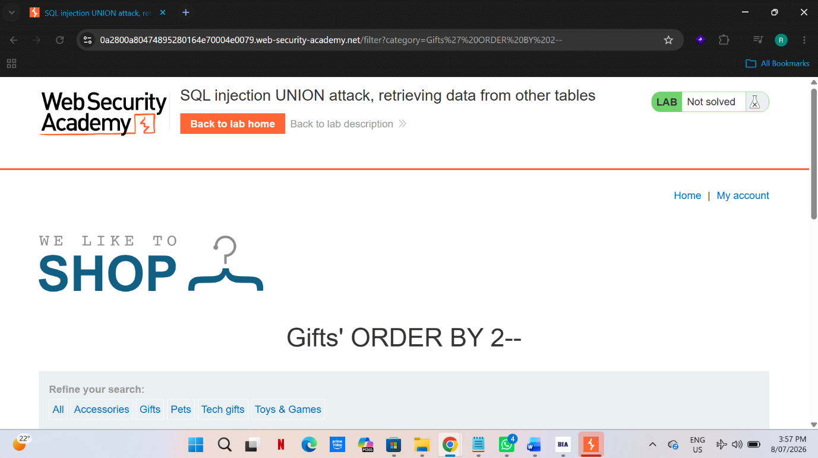

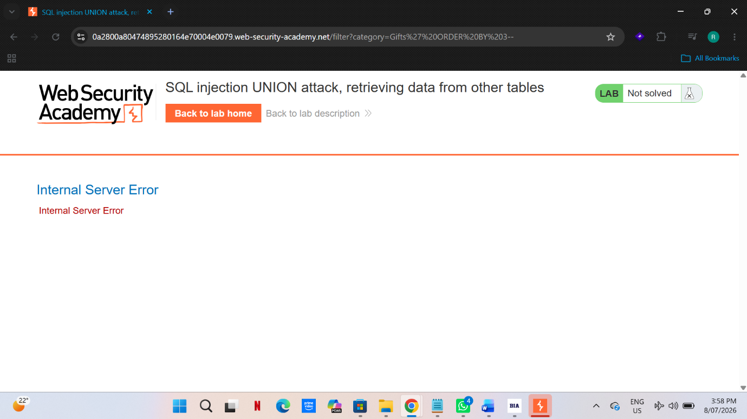

Step 4:

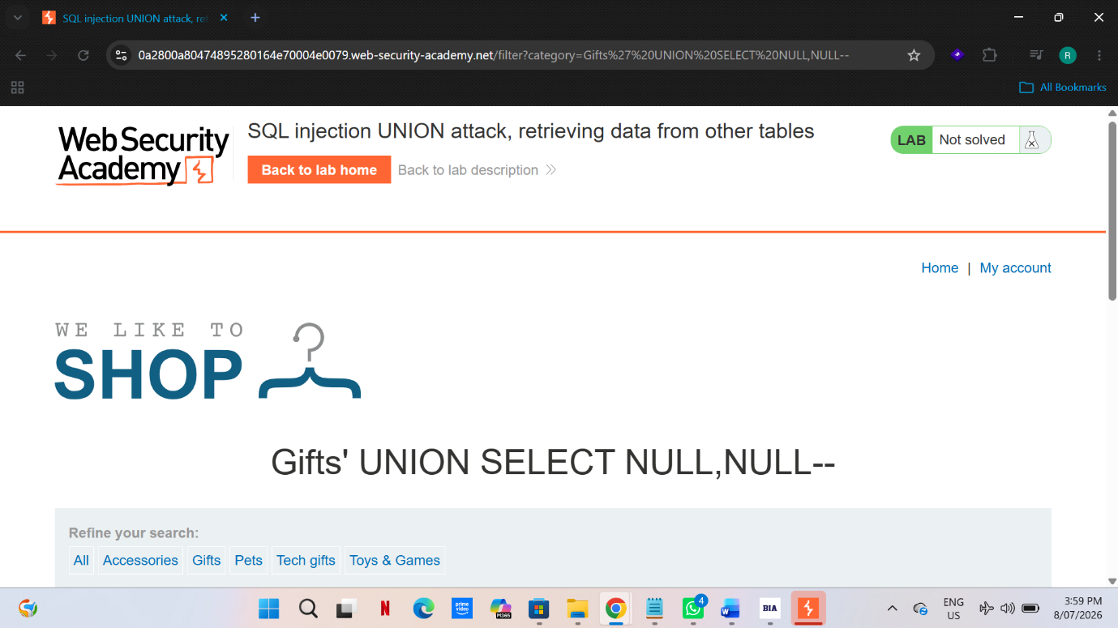

Step 5:

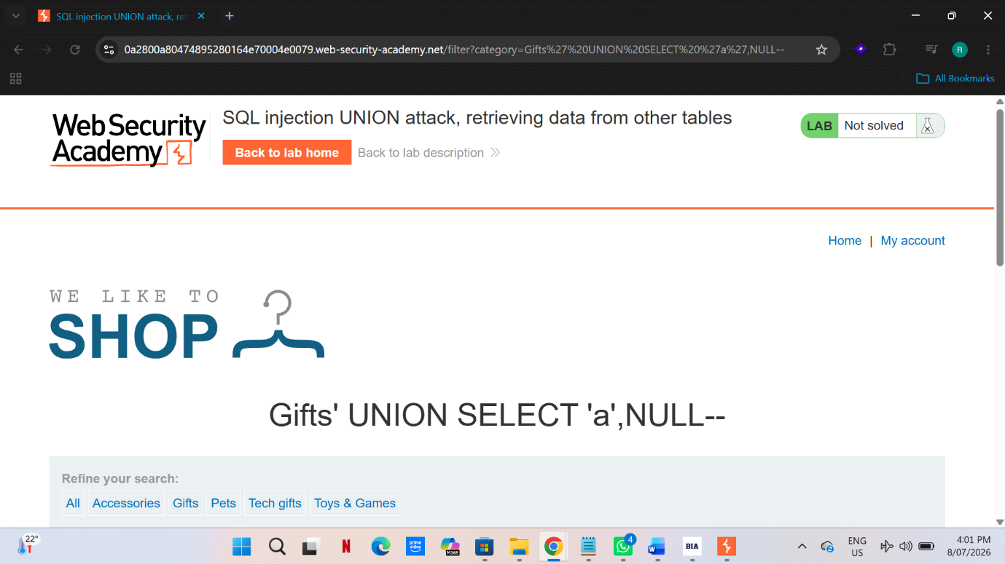

Step 6:
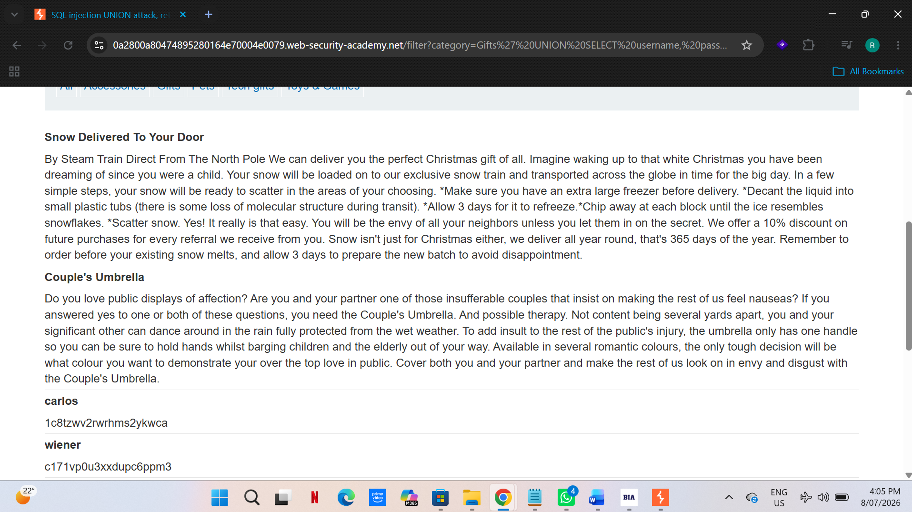

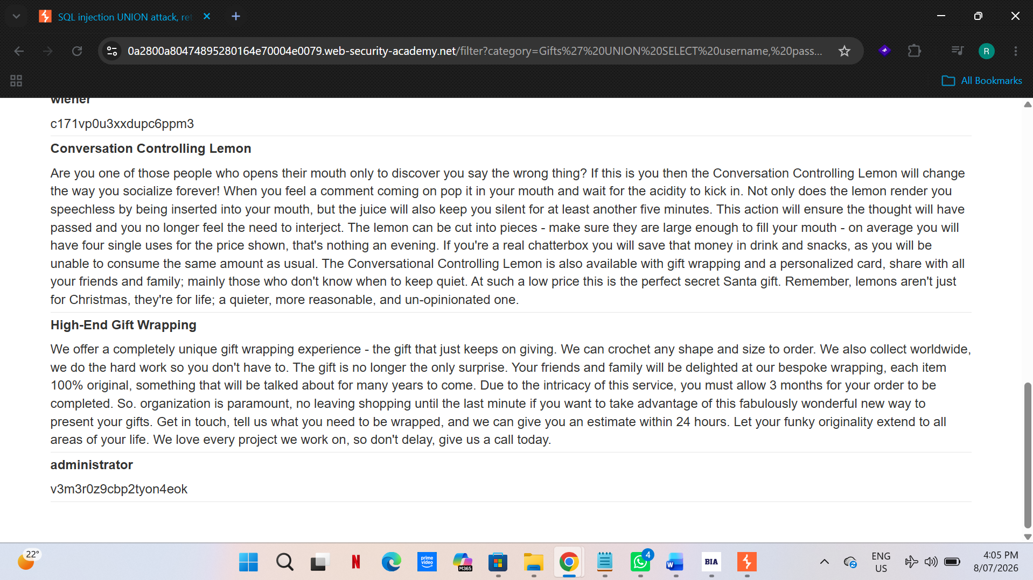

Step 7:

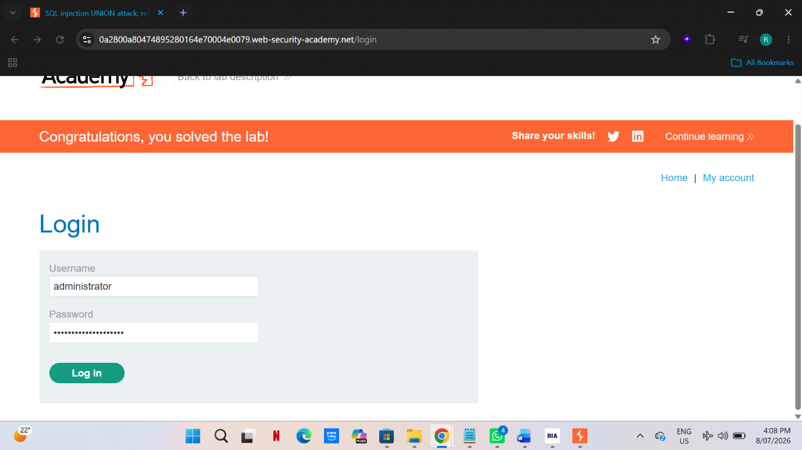

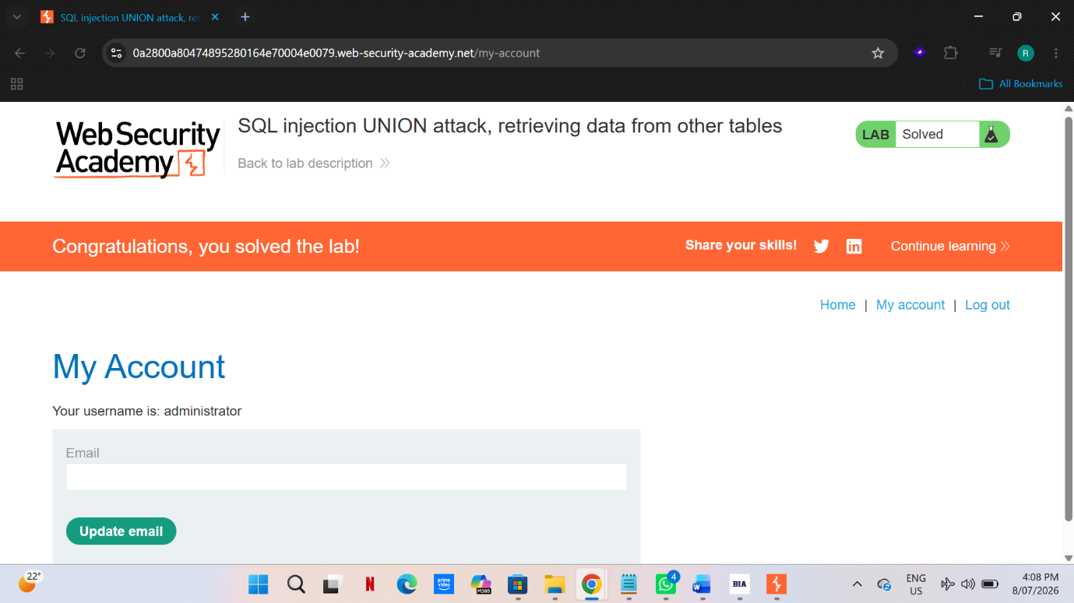

Chapter 6

Impact Analysis

As per my proof of the concept, I managed to extract valuable information from the database, including credentials and private data. This data could be sold or used in other malicious ways by the attackers, which creates a privacy issue since the unauthorised third party knows sensitive personal data. Additionally, the company will face financial losses due to penalties, a negative reputation, and a lack of trust from the clients. The SQLi attacks that allows an attacker to extract the maximum amount of data with the least effort are the union-based ones since they have a direct impact. For example, the database’s tables can be dumped in one request in order to obtain all the necessary data. Moreover, Boolean-based blind SQLi attacks are the least conspicuous but still carry a significant amount of damage with the same set of consequence. Time-based blind SQLi requires many requests as it is the slowest but works perfectly even if no visible difference is seen on the pages at all. However, the attack is still destructive since an attacker will manage to steal data with it eventually. Lastly, the out-of-band attacks are an additional option in terms of the blind SQLi, but require the server configuration to work.

Chapter 7 Recommendations

- Use of Parameterized Queries -he use of this technique allows separation of the user in put from other elements of the quey. This way, user input will not be treated as command execution instructions. As we can see from the PoC, I was able to directly inject my commands into the query via category parameter, something that would not happen if parameterized queries were in place.

- Least privilege accounts matter in the position because if the database account of the application is not granted permission to the table /column address on the URL bar, the query address on the URL bar change it to UNION SELECT username, password FROM users would have resulted in an access failure.

- Input Validation: This approach would help to make sure that the data used matches the expected format. The validation process must deny any data entry that does not match the expected standard. In this case, the implementation of this approach would have made it impossible for me to use SQL statements.

- Avoiding Verbose Error Messages: This involves the elimination of descriptive error messages as these could provide information that could help the attacker to break into the system.

- WAF: Web Application Firewall assist in preventing SQL injection attack in that it provides protection against the usual attacks in the applications, thus providing an additional layer of protection. However, the use of WAF is not sufficient to protect applications from SQL injection attacks.

- Hashing Algorithms: This involves creation of a method that uses cryptographic hashing algorithms to store passwords in the database. Once applied, the attackers cannot obtain the real passwords in the database, thus being unable to penetrate the system. In my PoC, the information stored in the database would have been secure if hashing was employed.

- Testing: This involves automated scanning and penetration testing in order to identify any weakness such as the one in the injection attack that I demonstrated on the PoC.

- References

- https://docs.oracle.com/en/database/oracle/oracle-database/19/sqlrf/Introduction-to-Oracle-SQL.html

- https://www.oracle.com/database/what-is-database/

- https://portswigger.net/web-security/sql-injection?/

- https://corewin.ua/en/blog-en/what-is-the-cause-of-sql-injection/

- https://owasp.org/www-community/attacks/SQL_Injection

- https://portswigger.net/web-security/sql-injection/blind#extracting-sensitive-data-via-verbose-sql-error-messages

- https://portswigger.net/web-security/sql-injection/union-attacks.

- https://beaglesecurity.com/blog/vulnerability/boolean-based-blind-sqli.html

- https://portswigger.net/web-security/sql-injection/blind

- https://portswigger.net/web-security/sql-injection/blind

